

**CHRISTMAS TREE HILL NEIGHBORHOOD RESPONSE GROUP (CTH NRG)**

ZONE ___ BLOCK ___

Block Captain Name:

Address:

Phone Number:

Dear Neighbors,

I am writing to you on behalf of the CTH NRG, an initiative designed to ensure that all residents of Christmas Tree Hill are prepared to respond as effectively as possible to a disaster like a wildfire or an earthquake. The CTH NRG is comprised of a group of concerned Hill residents who volunteer to serve as block captains and members of an emergency incident command team whose primary mission it is to assist you to prepare as adequately as possible for a major emergency or disaster. For more details about NRGs see: [Www.NRGMarin.org](http://www.nrgmarin.org/).

As evidenced by the 2017 Napa-Sonoma and Southern California wildfires, major disasters can occur at any time with devastating consequences and Christmas Tree Hill—which is at significant risk of wildfires and lies close to a major fault line—poses major challenges to emergency first responders. Our narrow streets, limited evacuation routes, steep terrain, an abundance of underbrush fuel and tall trees all serve to create an environment in which residents must be as prepared as possible to respond to a major emergency or disaster.

In the event of an emergency or disaster, volunteer staffing permitting, the CTH NRG will mobilize an Incident Command Team to coordinate response activity, assess impacts, and assist first responders. In addition to urging you to have a sound emergency response plan and assisting you when possible with information and resources, the NRG’s goal is to encourage you to get to know your surrounding neighbors. Disaster recovery history shows that neighbors-helping-neighbors in the aftermath of disasters saves lives and protects property.

If our area experiences a major earthquake or fire, Corte Madera and Larkspur authorities have cautioned us that residents may be left to fend for themselves anywhere from 2 to 5 days—depending on the scale of the destruction—because first responders may be overwhelmed until state and federal assistance arrives. During such a time neighbors—working in a coordinated way through the NRG—may well be the only assistance available. The NRG program stresses self-reliance and a neighbor-helping-neighbor approach and has as a goal ensuring that no home or resident is overlooked.

Before, during, and after an emergency or disaster a Block Captain is responsible for information sharing, 2-way radio communication with Incident Command and other Block Captains, and impact assessment, as described in brief below:

* Conduct door-to-door surveys of assigned homes. Look for ‘OK’ and ‘HELP’ signs; prioritize ‘HELP’ and ‘NO SIGN’ homes.
* Using the form provided assess injuries and damage and report conditions promptly to IC. If you have CERT or First Aid training, provide hands-on first aid assistance.
* **NO SIGN**: Knock loudly, repeatedly and identify yourself. Do not enter unless you see or hear someone needing help.
* **HELP SIGN**: Knock and call, if no response, immediately report location to Incident Command.
* **UNINHABITABLE HOME** (as determined by homeowner): Recommend occupants shelter with a neighbor or use camping equipment (if any) and remain on own property, if safe to do so.
* **HABITABLE HOMES (**as determined by homeowner): Recommend residents remain if no ongoing threat.
* Record all inspected households on clipboard form.
* Coordinate assistance through Incident Command.
* Remain in neighborhood; monitor block until Incident Command or the authorities declare the emergency is over.

Serious injuries or hazards will be called in by 2-way radio immediately, all other information will be made in one combined report when the block assessment is complete.

**To prepare adequately the CTH NRG urges you to take the following important steps:**

1. **COMPLETE THE ATTACHED PERSONAL INFORMATION FORM AS SOON AS POSSIBLE AND RETURN IT TO ME:** Your information will be entered into a confidential data base and will only be available to the CTH NRG Block Captains and the Incident Command Team. The information you provide will be used only for emergency preparedness and response purposes.
2. **PREPARE A FAMILY EMERGENCY RESPONSE PLAN:** The sites below (and many others) provide excellent emergency preparedness guidance, checklists, alerts, and supply kit content lists and purchase options.

[www.ReadyMarin.org](http://www.readymarin.org/)

[Www.NRGMarin.org](http://www.nrgmarin.org/)

[https://local.nixle.com/city/ca/](https://local.nixle.com/city/ca/larkspur/)

<https://www.ready.gov/wildfires>

<https://www.ready.gov/floods>

<https://www.ready.gov/earthquakes>

<https://www.ready.gov/animals>

<https://www.marinsheriff.org/services/emergency-services/alert-marin>

<https://www.ready.gov/individuals-access-functional-needs>

<https://www.fema.gov/pdf/areyouready/areyouready_full.pdf>

<http://www.redcross.org/get-help/prepare-for-emergencies/be-red-cross-ready/get-a-kit>

<http://www.nsc.org/learn/safety-knowledge/Pages/safety-at-home-emergency-preparedness>

1. **KNOW HOW TO SHUT OFF YOUR GAS: If your shut-off valve is stuck or rusted closed we suggest you contact PG&E immediately for assistance.** Turn off your gas valve if you smell gas. We suggest that you buy a wrench just for this purpose and leave it in close proximity to the meter.
2. **BE PREPARED BY BEING EDUCATED AND HAVING INFORMATION:** We strongly recommend that you take the following actions as soon as you can:

* **Sign up for Marin.org alerts as soon as possible:**

<https://www.marinsheriff.org/services/emergency-services/alert-marin>

* **Sign up for Nixle alerts as soon as possible:** [https://local.nixle.com/city/ca/](https://local.nixle.com/city/ca/larkspur/)
* Walk your block, know the entrance and exist points of the homes in your block.
* Study a map of the hill and of your block carefully, [https://www.google.com/maps](https://nextdoor.com/neighborhood/christmastreehill--corte-madera--ca/)

<https://nextdoor.com/neighborhood/christmastreehill--corte-madera--ca/>

Find and become familiar with the evacuation routes and fire roads nearest to your home and block and take note of any unusual barriers or obstacles to evacuation.

* Try your best to attend CERT emergency preparedness and response training:

<https://readymarin.org/calendar/>

1. **CONSIDER BECOMING A CTH NRG VOLUNTEER:** The CTH NRG Steering Committee meets once a month on a Sunday at 4:00 PM (usually the third or fourth Sunday of the month) at the Corte Madera Town Hall. All residents are welcome at the meetings. Once you provide your email address you will be notified of meeting dates and times.

The CTH NRG meets monthly on the third Sunday of the month @ 4:00 PM at the Corte Madera Town Hall. Please consider joining us at an upcoming meeting and please do not hesitate to contact me if you have questions or if I can assist you with your emergency/disaster preparation in any way. A ‘HELP/OK sign with instructions for use and a blood stop kit are enclosed.

Sincerely,

CTH NRG Block Captain

Attachments/Enclosures:

1. Zone/Block Map - most current version
2. **Personal Information Form - please complete and return as soon as possible**
3. CTH NRG Volunteer Application Form
4. HELP/OK Sign (if possible under the circumstances, to be placed in a highly visible place for viewing by first responders and NRG volunteers)
5. Blood Stop Kit

**ATTACHMENT 1: MOST CURRENT VERSION OF CTH NRG ZONE/BLOCK MAP**

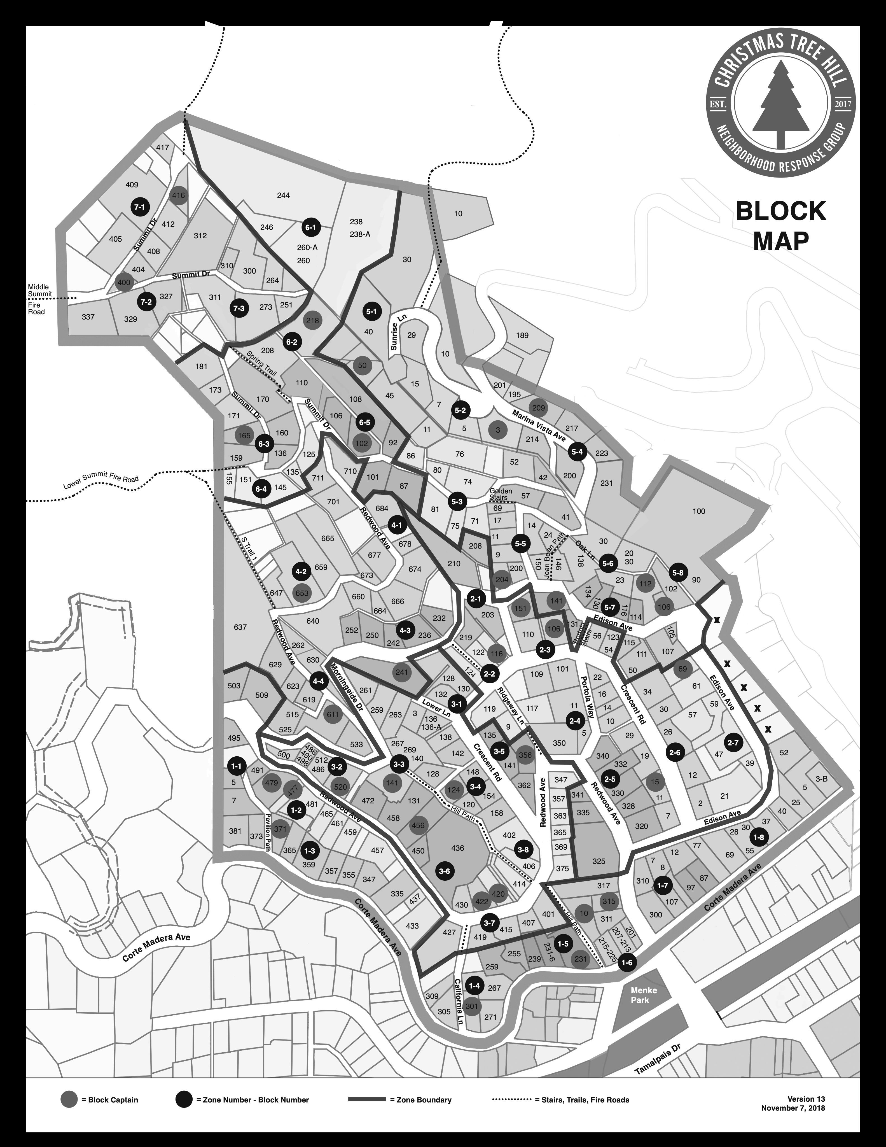

**ATTACHMENT 2**

**RESIDENT INFORMATION FORM**

**PLEASE RETURN TO BLOCK CAPTAIN OR** [**CTHNRG@gmail.com**](mailto:CTHNRG@gmail.com) **AS SOON AS POSSIBLE**

Dear Neighbor,

Thank you for filling out the form below. Please be assured that your information will be treated as confidential and will be shared only with the CTH NRG ER Team and is solely for the purpose of assisting you to prepare for, respond to, and recover from a major emergency or disaster.

1. Address:
2. Adult residents’ first and last names:
3. Children's first and last names and birth year:
4. Home phone:
5. Cell phone(s):
6. Work phone/phone(s):
7. Primary email address/addresses:
8. Emergency contact(s) not in our earthquake zone:

Name:

Phone:

Name:

Phone:

1. Pet(s) Name(s) and Type(s):
2. What additional information would be important for rescue workers to know about your household members? (E.g., wheelchair-bound, disabled, elderly, hard of hearing, medical conditions, etc.):
3. Has any adult in your household attended emergency preparedness training?

* GET READY CLASS:
* CERT TRAINING:
* OTHER (describe):

1. Does any adult in the household have medical training? (please specify):
2. Do you have resources that could be used in disaster recovery?

* A pick-up truck or 4-wheel drive?
* A chainsaw?
* A generator?
* Other equipment/supplies that could be used in recovery efforts?

1. Does any adult in the household have armed forces, National Guard, police, or fire training? (please specify who and type of training)
2. Does any adult in the household have hands-on disaster response/recovery experience? (please specify who)
3. Is there any other emergency preparedness related information you wish to share with us?

**Please notify me if any significant change occurs in the information you have provided to the NRG, or if you make plans to move away, so that the emergency response data base can be updated.**

Thank you!

The CTH NRG Team

**ATTACHMENT 3**

**CHRISTMAS TREE HILL NEIGHBORHOOD EMERGENCY RESPONSE GROUP**

**VOLUNTEER APPLICATION FORM**

**If you are interested in becoming involved as a volunteer please complete the information on this form and deliver it to your Block Captain or email it to:** [**CTHNRG@gmail.com**](mailto:CTHNRG@gmail.com)

**NAME:**

**ADDRESS:**

**TELEPHONE NUMBER:**

**EMAIL ADDRESS:**

**AREA OF INTEREST: I am interested in volunteering to assist the CTH NRG in one or more of the following categories - check all that apply**

* Block Captain
* Zone Coordinator
* Member of the NRG Steering Committee
* Medical Team Member
* Administrative assistance
* Web development and maintenance
* Graphic Art (for flyers, website, etc.)
* Preparedness drill organization and coordination
* Manning NRG booths at local events
* Making copies of needed documents
* Providing emergency supplies like backpacks, batteries, flashlights
* Fundraising
* Donating funds for supplies and overhead
* Other:

**Thank you for expressing an interest in volunteering for the CTH NRG!**